CHRIST LUTHERAN

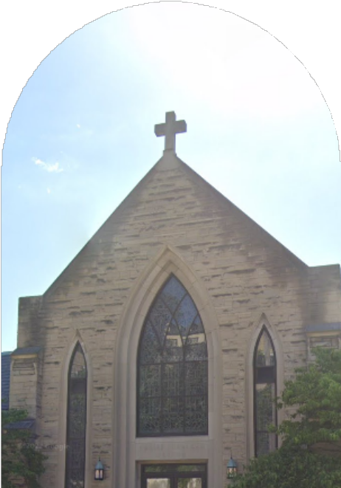

CHURCH

WEEKLY BULLETIN

N O V E M B E R 2 4 , 2 0 2 4

COME

WORSHIP WITH US

November 24 at 9:30

Daniel 7:9-10 Revelation 1:4b-8 John 18:33--37

In person worship FIRST READING SECOND READING

GOSPEL



Even after Israel had experienced the vagaries of kings, the people still longed for a true king to set things right. He would have the king’s title of Anointed One (Messiah); he would be the “one like a human being” (Son of Man) given dominion in Daniel’s vision. Jesus is given these titles, even though he is nothing like an earthly king. His authority comes from the truth to which he bears witness, and those who recognize the truth voluntarily listen to him. We look forward to the day he is given dominion, knowing his victory will be the nonviolent victory of love.



FOOD



PANTRY AT CLC

**The food pantry**

**is open Mon. & Fri. 9:30-11:30am, and on Wed. from 5- 7pm**

**Donations Needed for Thanksgiving...**

**\*Stuffing**

**\*Potatoes**

**\*Canned Yams**

**\*Cranberry Sauce**

**\*Green Beans**

**\*Corn**

**\*Gravy**

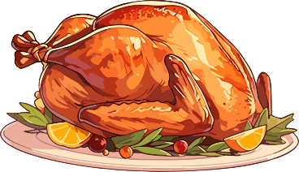

Whatever help you can offer, we will gladly accept.

We receive a food truck once per month on the second Monday of the month from 412 Food Rescue. We can always use help unloading!

Volunteers Needed for Monday



November 25th from 5-7pm to hand out turkeys. Please

sign up if you can help

**Reminder**

**Advent Wreath making event today at 3pm**

Congregational Meeting December 1st after church.

Saturday Dec.7th at 9am Volunteers needed

to set up Christmas decorations and trees

**Infant Room/Children**

**All children are welcome in worship and can play quietly at our pray ground in the side aisle. If you need a quiet space, please use the room at the top of the stairs.**

THIS WEEK

AT CLC



In case of emergency, there is a defibrillator on the wall near the office. Narcan is available in the first aid kits in the narthex and office

**Sunday, November 24 8:30 am Sunday School**

**9:30 am In-person worship service Advent wreath event 3pm**

**Monday, November 25 9:30-11:30 am Food Pantry 5-6 pm Tops Club, Tai Chi Turkey Pick up 5-7pm**

**Tuesday, November 26**

**9:30-11:30 am ESL in Library,**

**Wednesday, November 27**

**5-7 pm Food Pantry**

**6pm Choir**

**Thursday, November 28**

**6:30-7 pm Scouts**

**Happy Thanksgiving Office Closed**

**Friday, November 29 9:30-11:30 am Food Pantry 7 pm NA meets in Library 6-8 Girl Scouts**

**Saturday, November 30**

**9 am AA meets in Library**

**7 pm NA meets in Library**

The Reverend Tricia Schneck, Pastor Mickey Donati, Organist & Director of Music



917 Evergreen Avenue

Millvale, PA 15209

Phone: 412-821-4300 ⟡ Fax: 412-693-9742

[ChristLutheran917@gmail.com](mailto:ChristLutheran917@gmail.com)

The best way to contact Pastor Tricia is by email at [tricia.schneck@yahoo.com](mailto:tricia.schneck@yahoo.com)

[](https://www.clcmillvale.com/)

